### Z-Axis and Z-axis plates

*Plates, Shafts, Mounts & Design*

Throughout this project I was tasked with the designing Z-Axis although our group left off from another we had to re-create draw and draft the lathe as a lot of design components were wrong due to miss measurements. Some of the difficulties we faced during this project, was completely removing the apron of the lathe meaning we had to redesign the placement of the motor and the motor mounts which also affect the mounting positions of the ball screw, after doing that and doing some test fits we found the plates that were originally designed by the last group weren’t going to work anymore as they did fit in the mounting positions on the lathe, so it was my job to redesign them to work.

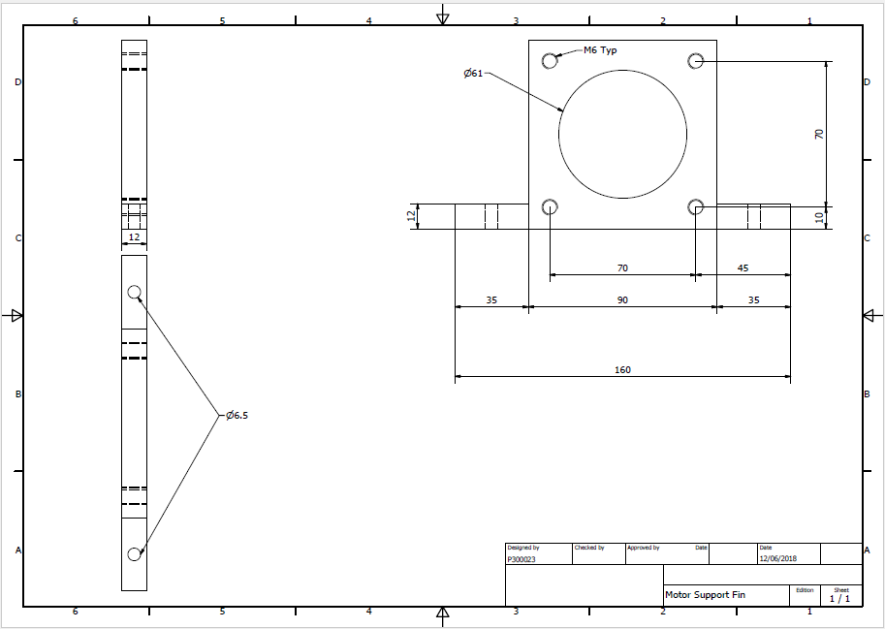Motor Mount Fin

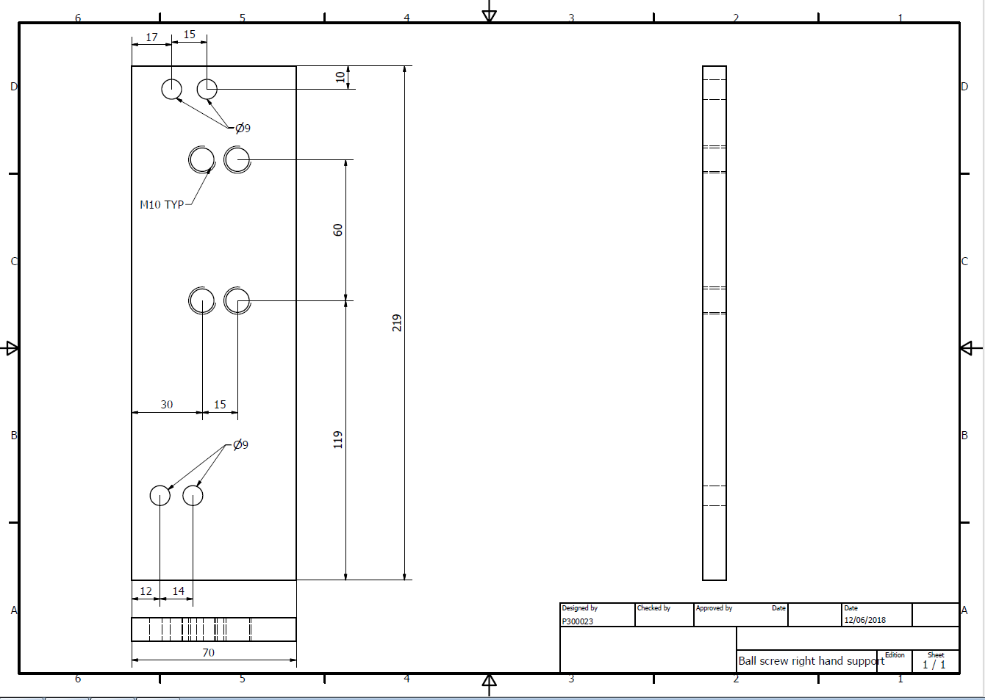Ball Screw Bearing Block Plate

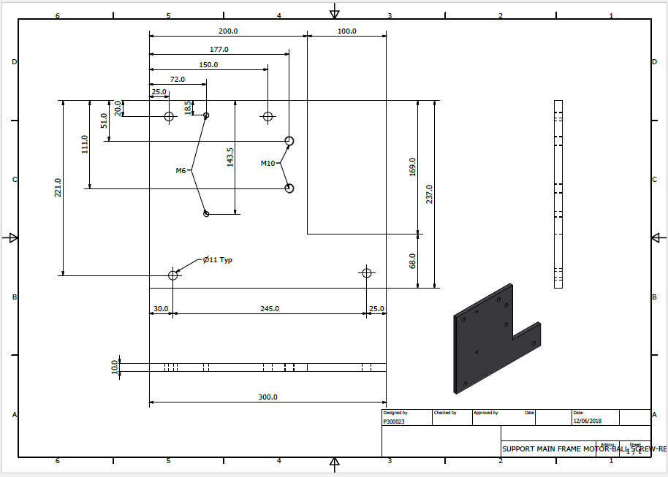Motor Mount Base Plate

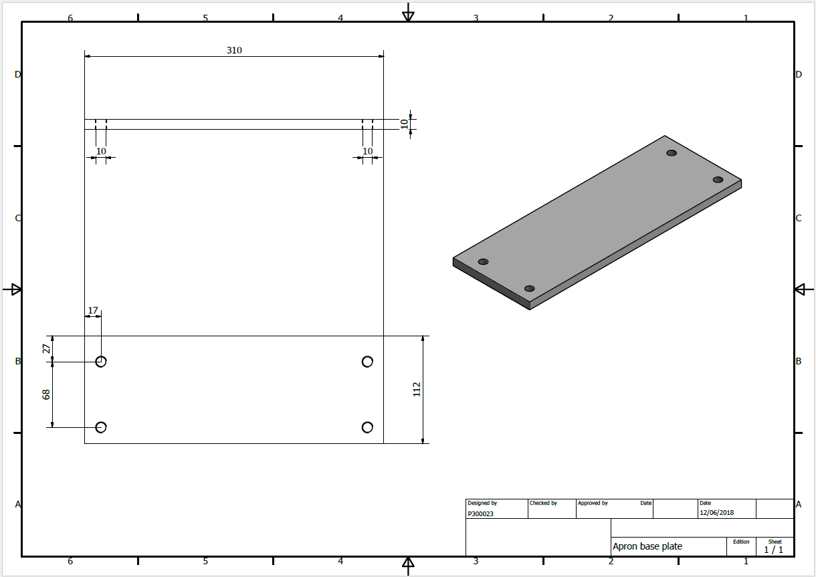Apron Base Plate